./

# Design and Implementation of a System in Medical department for Covid Management

**Contents**

1. *System OR software development* 
   1. *PROBLEM DEFINITION*
   2. *RESEARCH ON PROJECT*
   3. *SWOT ANALYSIS*
   4. *REQUIREMENTS* 
      1. *HIGH LEVEL REQUIREMENTS*
      2. *LOW LEVEL REQUIREMENTS*
2. ***DESIGN***
   1. *STRUCTURAL DESIGN*
   2. *BEHAVIORAL DESIGN*
3. ***TEST PLAN***
4. ***TEST CASES***
5. ***REFERENCES***

**Table of figures**

|  |  |  |  |
| --- | --- | --- | --- |
| **SL.NO** | **Figure number** | **Figure name** | **Page number** |
| **1** | **1.1** | **Rapidly growing corona cases in various states of India.** | **7** |
| **2** | **2.1** | **Class diagram for COVID management system** | **9** |
| **3** | **2.2** | **Flow chart to calculate the percentage calculation of recovery rate** | **10** |

**List of tables**

|  |  |  |  |
| --- | --- | --- | --- |
| **SL.NO** | **Table number** | **Table name** | **Page number** |
| **1** | **1.1** | **SWOT Analysis** | **8** |
| **2** | **1.2** | **High level requirements** | **8** |
| **3** | **1.3** | **Low level requirements** | **8** |
| **4** | **3.1** | **Test plan for Covid management system** | **10** |
| **5** | **3.2** | **Test case for Covid management system** | **13** |

# Design and Implementation of a System in Medical department for Covid Management

**1. System or software development**

* 1. **Problem Statement**
* To build a system which is used to count the Corona virus disease (COVID) cases on daily basis in local hospitals.
* To count various attributes related to covid as follows:
* Number of patients visited, Number of patients tested positive, number of patients tested negative, number of patients died, number of patients recovered, number of people who are home quarantined, number of patients revisited the hospital, number of patients revisited and has been tested positive and negative, number of people in hospital quarantined, number of people who completed isolation, number of people from different state and has been tested positive and negative, number of people infected from primary and secondary contact.

**1.2. Research on the project**

Corona virus disease (COVID-19) is an infectious disease caused by a newly discovered corona virus.

Most people infected with the COVID-19 virus will experience mild to moderate respiratory illness and recover without requiring special treatment.  Older people, and those with underlying medical problems like cardiovascular disease, diabetes, chronic respiratory disease, and cancer are more likely to develop serious illness.

The best way to prevent and slow down transmission is be well informed about the COVID-19 virus, the disease it causes and how it spreads. This needs a system which records the count on the daily basis of covid cases and various parameters associated.

According to the reports by WHO this virus spread is being rapidly growing. So the old style of recording through pen and paper may lead to missing of some important data due to human intervention. Hence there arose a demand for the system which manages the data and keeps the count of data on daily basis.

Hence proposed system can be implemented to satisfy all the demands and needs.

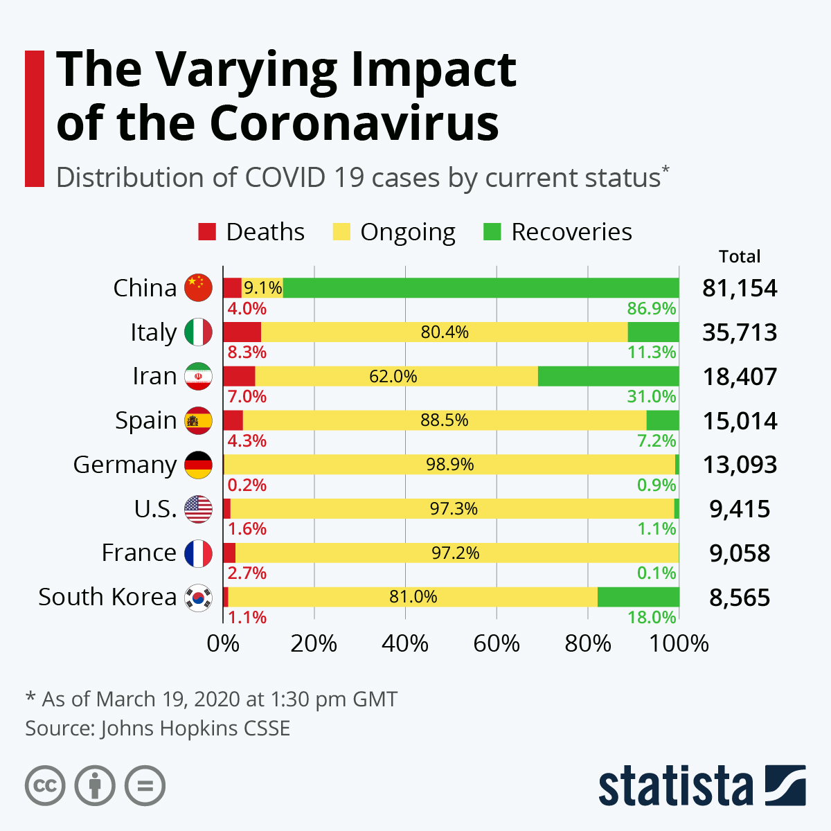

**Fig 1.1: Rapidly growing corona cases in various Countries.**

**1.3 SWOT Analysis**

**Table 1.1: SWOT Analysis**

|  |  |
| --- | --- |
| * **Strengths** * **Proper management of data.** * **Proper calculation of statics from data.** * **No loss of data.** | * **Weakness** * **Network and connectivity issues.** * **Maintenance and Replacement is costly.** |
| * **Threats** * **Competitors both existing and new.** * **Expensive database.** | * **Opportunities** * **Use of new technology to manage data easily.** * **Does not require more human intervention.** |

* 1. **REQUIREMENTS**
     1. **HIGH LEVEL REQUIREMENTS**

**Table 1.2: High level requirements**

|  |  |
| --- | --- |
| **ID** | **Description** |
| HL1 | Patients visited |
| HL2 | Patients infected |
| HL3 | Patients died |
| HL4 | Patients recovered |
| HL5 | Patients revisited |
| HL6 | Patients Quarantined |
| HL7 | Patients from different state |
| HL8 | Patients infected from contacting other people |
| HL9 | Percentage calculation for parameters |

* + 1. **LOW LEVEL REQUIREMENTS**

**Table 1.3: Low level requirements**

|  |  |
| --- | --- |
| **ID** | **Description** |
| HL1_L1 | Addition of people visiting hospital |
| HL2_L1 | Patients infected and tested positive after the test |
| HL2_L2 | Patients visited the hospital and tested negative after the test |
| HL3_L1 | Patients who had tested positive before and has died |
| HL4_L1 | Patients who had tested positive before and has recovered |
| HL5_L1 | Patients revisited the hospital and are tested positive |
| HL5_L2 | Patients revisited the hospital and are tested negative |
| HL6_L1 | Patients who have tested positive and are home quarantined |
| HL6_L2 | Patients who have tested positive and are hospital quarantined |
| HL6_L3 | Patients who have completed 14 days isolation |
| HL7_L1 | Patients visiting from different state and being tested positive |
| HL7_L2 | Patients visiting from different state and being tested negative |
| HL8_L1 | Patients infected from primary contact |
| HL8_L2 | Patients infected from secondary contact |
| HL9_L1 | Percentage calculation of infected rate |
| HL9_L2 | Percentage calculation of death rate |
| HL9_L3 | Percentage calculation of recovery rate |

**2.0 Design**

**2.1 Structural design**

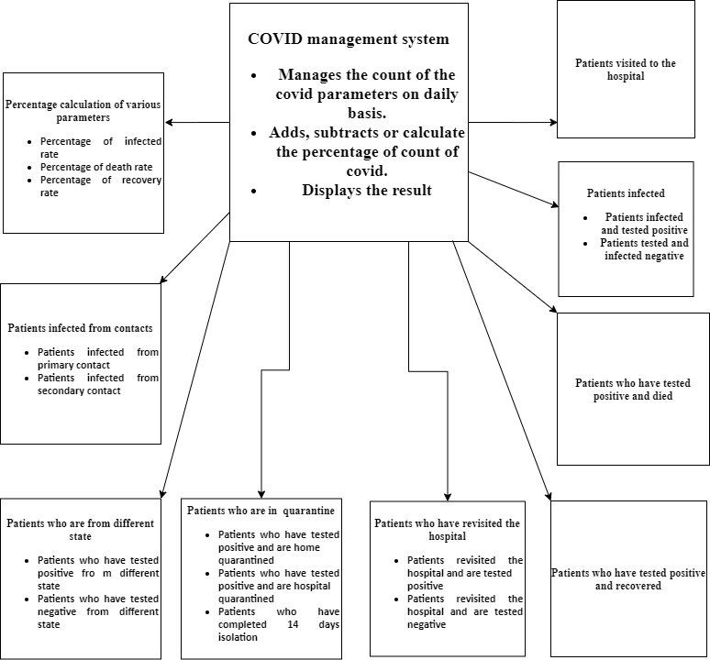

**Fig 2.1: Class diagram for COVID management system**

**2.2 Behavioral design**

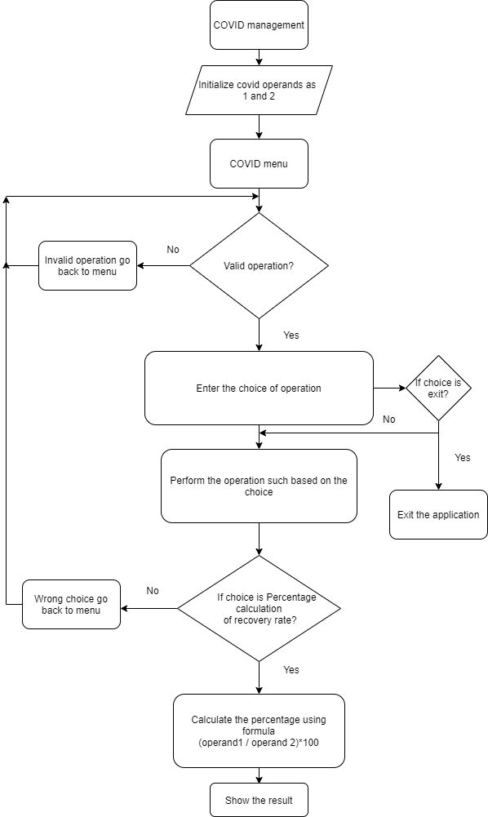

**Fig 2.2: Flow chart to calculate the percentage calculation of recovery rate**

**3.0 Test plan**

**Table 3.1: Test plan for Covid management system**

|  |  |  |  |  |  |
| --- | --- | --- | --- | --- | --- |
| ID | Description | Pre-Condition | Expected Input | Expected Output | Actual Output |
| HL1_L1_1 | Number of patients visited | Choose visits from all the covid operations | Two int operands | Sum of the two operands |  |
| HL1_L1_1 | Number of patients visited | Choose visits from all the covid operations | Any one operand is not valid | Error value as the return value |  |
| HL2_L1_1 | Number of patients visited and tested positive | Choose infected positive from all covid operations | Two int operands | Sum of the two operands |  |
| HL2_L1_1 | Number of patients visited and tested positive | Choose infected positive from all covid operations | Any one operand is not valid | Error value as the return value |  |
| HL2_L2_1 | Number of patients visited and tested negative | Choose infected negative from all covid operations | Two int operands | Subtract the two operands |  |
| HL2_L2_1 | Number of patients visited and tested negative | Choose infected negative from all covid operations | Any one operand is not valid | Error value as the return value |  |
| HL3_L1_1 | Number of patients tested positive and died | Choose infected positive and died from all operations | Two int operands | Sum of the two operands |  |
| HL3_L1_2 | Number of patients tested positive and died | Choose infected positive and died from all operations | Any one operand is not valid | Error value as the return value |  |
| HL4_L1_1 | Number of patients tested positive and recovered | Choose infected positive and recovered from all operations | Two int operands | Subtract the two operands |  |
| HL4_L1_1 | Number of patients tested positive and recovered | Choose infected positive and recovered from all operations | Any one operand is not valid | Error value as the return value |  |
| HL5_L1_1 | Number of patients revisited the hospital and tested positive | Choose revisited and positive from all operations | Two int operands | Sum of the two operands |  |
| HL5_L1_2 | Number of patients revisited the hospital and tested positive | Choose revisited and positive from all operations | Any one operand is not valid | Error value as the return value |  |
| HL5_L2_1 | Number of patients revisited the hospital and tested negative | Choose revisited and negative from all operations | Two int operands | Subtract the two operands |  |
| HL5_L2_2 | Number of patients revisited the hospital and tested negative | Choose revisited and negative from from all operations | Any one operand is not valid | Error value as the return value |  |
| HL6_L1_1 | Number of patients who are home quarantined | Choose infected positive and home quarantined from all operations | Two int operands | Sum of the two operands |  |
| HL6_L1_2 | Number of patients who are home quarantined | Choose infected positive and home quarantined from all operations | Any one operand is not valid | Error value as the return value |  |
| HL6_L2_1 | Number of patients who are hospital quarantined | Choose infected positive and hospital quarantined from all operations | Two int operands | Sum of the two operands |  |
| HL6_L2_2 | Number of patients who are hospital quarantined | Choose infected positive and hospital quarantined from all operations | Any one operand is not valid | Error value as the return value |  |
| HL6_L3_1 | Number of patients who have completed 14 days isolation | Choose infected positive and completed 14 days isolation from all operations | Two int operands | Sum of the two operands |  |
| HL6_L3_2 | Number of patients who have completed 14 days isolation | Choose infected positive and completed 14 days isolation from all operations | Any one operand is not valid | Error value as the return value |  |
| HL7_L1_1 | Number of patients who are different state and tested positive | Choose infected positive from different state from all operations | Two int operands | Sum of the two operands |  |
| HL7_L1_2 | Number of patients who are different state and tested positive | Choose infected positive from different state from all operations | Any one operand is not valid | Error value as the return value |  |
| HL7_L2_1 | Number of patients who are different state and tested negative | Choose infected negative from different state from all operations | Two int operands | Sum of the two operands |  |
| HL7_L2_2 | Number of patients who are different state and tested negative | Choose infected negative from different state from all operations | Any one operand is not valid | Error value as the return value |  |
| HL8_L1_1 | Number of patients who are affected from primary contact | Choose infected from primary contact from all operations | Two int operands | Sum of the two operands |  |
| HL8_L1_2 | Number of patients who are affected from primary contact | Choose infected from primary contact from all operations | Any one operand is not valid | Error value as the return value |  |
| HL8_L2_1 | Number of patients who are affected from secondary contact | Choose infected from secondary contact from all operations | Two int operands | Sum of the two operands |  |
| HL8_L2_2 | Number of patients who are affected from secondary contact | Choose infected from secondary contact from all operations | Any one operand is not valid | Error value as the return value |  |
| HL9_L1_1 | Percentage of infected rate | Choose percentage of infected rate from all operations | Two non zero int operands | Percentage of two operands |  |
| HL9_L1_2 | Percentage of infected rate | Choose percentage of infected rate from all operations | Two int operands with divisor0 | Divide by 0 error |  |
| HL9_L2_1 | Percentage of death rate | Choose percentage of death rate from all operations | Two non zero int operands | Percentage of two operands |  |
| HL9_L2_2 | Percentage of death rate | Choose percentage of death rate from all operations | Two int operands with divisor0 | Divide by 0 error |  |
| HL9_L3_1 | Percentage of recovery rate | Choose percentage of recovery rate from all operations | Two non zero int operands | division of two operands |  |
| HL9_L3_2 | Percentage of recovery rate | Choose percentage of recovery rate from all operations | Two int operands with divisor0 | Divide by 0 error |  |

**4.0 Test cases**

**Table 4.1: Test cases for Covid management system**

|  |  |  |  |  |  |  |
| --- | --- | --- | --- | --- | --- | --- |
| ID | Description | Pre-Condition | Expected Input | Expected Output | Actual Output | Test Result |
| HL1_L1_1 | Number of patients visited | Choose visits from all the covid operations | Two int operands  visits(10, 20) | 30 | 30 | PASS |
| HL1_L1_1 | Number of patients visited | Choose visits from all the covid operations | Two int operands  visits(750, 7500) | 8250 | 1500 | FAIL |
| HL2_L1_1 | Number of patients visited and tested positive | Choose infected positive from all covid operations | Two int operandspositive(0, 3) | 3 | 3 | PASS |
| HL2_L1_1 | Number of patients visited and tested positive | Choose infected positive from all covid operations | Two int operands positive(1000, 900) | 1900 | 1 | FAIL |
| HL2_L2_1 | Number of patients visited and tested negative | Choose infected negative from all covid operations | Two int operandsnegative(10, 3) | 7 | 7 | PASS |
| HL2_L2_1 | Number of patients visited and tested negative | Choose infected negative from all covid operations | Two int operands negative(1000, 900) | 100 | 1 | FAIL |
| HL3_L1_1 | Number of patients tested positive and died | Choose infected positive and died from all operations | Two int operandsdied(20, 7) | 27 | 27 | PASS |
| HL3_L1_2 | Number of patients tested positive and died | Choose infected positive and died from all operations | Two int operands died(100, 2500) | 2600 | 1025 | FAIL |
| HL4_L1_1 | Number of patients tested positive and recovered | Choose infected positive and recovered from all operations | Two int operandsrecovered(16, 3) | 13 | 13 | PASS |
| HL4_L1_1 | Number of patients tested positive and recovered | Choose infected positive and recovered from all operations | Two int operands recovered(1080, 900) | 180 | 106 | FAIL |
| HL5_L1_1 | Number of patients revisited the hospital and tested positive | Choose revisited and positive from all operations | Two int operandsrevisitedpos(23, 33) | 56 | 56 | PASS |
| HL5_L1_2 | Number of patients revisited the hospital and tested positive | Choose revisited and positive from all operations | Two int operands revisitedpos(1900, 990) | 1890 | 1999 | FAIL |
| HL5_L2_1 | Number of patients revisited the hospital and tested negative | Choose revisited and negative from all operations | Two int operands revisitedneg(80, 70) | 10 | 10 | PASS |
| HL5_L2_2 | Number of patients revisited the hospital and tested negative | Choose revisited and negative from from all operations | Two int operands revisitedneg(1450, 900) | 550 | 1999 | FAIL |
| HL6_L1_1 | Number of patients who are home quarantined | Choose infected positive and home quarantined from all operations | Two int operands homequarant(18, 70) | 88 | 88 | PASS |
| HL6_L1_2 | Number of patients who are home quarantined | Choose infected positive and home quarantined from all operations | Two int operands homequarant(1450, 900) | 550 | 1999 | FAIL |
| HL6_L2_1 | Number of patients who are hospital quarantined | Choose infected positive and hospital quarantined from all operations | Two int operands hospquarant(80, 20) | 100 | 100 | PASS |
| HL6_L2_2 | Number of patients who are hospital quarantined | Choose infected positive and hospital quarantined from all operations | Two int operands hospquarant(1386, 800) | 586 | 166 | FAIL |
| HL6_L3_1 | Number of patients who have completed 14 days isolation | Choose infected positive and completed 14 days isolation from all operations | Two int operands compisolation(8050, 50) | 8100 | 8100 | PASS |
| HL6_L3_2 | Number of patients who have completed 14 days isolation | Choose infected positive and completed 14 days isolation from all operations | Two int operands compisolation(1550, 800) | 750 | 1458 | FAIL |
| HL7_L1_1 | Number of patients who are different state and tested positive | Choose infected positive from different state from all operations | Two int operands diffstatepos(80, 100) | 180 | 180 | PASS |
| HL7_L1_2 | Number of patients who are different state and tested positive | Choose infected positive from different state from all operations | Two int operandsdiffstatepos(2650, 200) | 2850 | 2665 | FAIL |
| HL7_L2_1 | Number of patients who are different state and tested negative | Choose infected negative from different state from all operations | Two int operands diffstateneg(150, 100) | 50 | 50 | PASS |
| HL7_L2_2 | Number of patients who are different state and tested negative | Choose infected negative from different state from all operations | Two int operands diffstateneg(2900, 200) | 2700 | 2905 | FAIL |
| HL8_L1_1 | Number of patients who are affected from primary contact | Choose infected from primary contact from all operations | Two int operands primecon(800, 800) | 1600 | 1600 | PASS |
| HL8_L1_2 | Number of patients who are affected from primary contact | Choose infected from primary contact from all operations | Two int operandsprimecon(1780, 200) | 1980 | 3560 | FAIL |
| HL8_L2_1 | Number of patients who are affected from secondary contact | Choose infected from secondary contact from all operations | Two int operands seccon(900, 80) | 980 | 980 | PASS |
| HL8_L2_2 | Number of patients who are affected from secondary contact | Choose infected from secondary contact from all operations | Two int operands seccon(2500, 40) | 2540 | 2540 | PASS |
| HL9_L1_1 | Percentage of infected rate | Choose percentage of infected rate from all operations | Two int operands infectedrate(200, 200) | 100 | 100 | PASS |
| HL9_L1_2 | Percentage of infected rate | Choose percentage of infected rate from all operations | Two int operands infectedrate(32, 500) | 64 | 26 | FAIL |
| HL9_L2_1 | Percentage of death rate | Choose percentage of death rate from all operations | Two int operands deathrate(10, 20) | 50 | 50 | PASS |
| HL9_L2_2 | Percentage of death rate | Choose percentage of death rate from all operations | Two int operands deathrate(8, 32) | 25 | 32 | FAIL |
| HL9_L3_1 | Percentage of recovery rate | Choose percentage of recovery rate from all operations | Two int operands recoveryrate(30, 40) | 75 | 75 | PASS |
| HL9_L3_2 | Percentage of recovery rate | Choose percentage of recovery rate from all operations | Two int operands recoveryrate(400, 100) | 40 | 200 | FAIL |

**4W’s and 1’H**

**WHO:** For the medical department to analyze the pandemic and spreading of Covid.

**WHAT:** To build a system which is used to count the Corona virus disease (COVID) cases on daily basis in local hospitals.

**WHEN:** The COVID-19 pandemic, also known as the coronavirus pandemic, is an ongoing [global pandemic](https://en.wikipedia.org/wiki/Pandemic#COVID-19) of [coronavirus disease 2019](https://en.wikipedia.org/wiki/COVID-19) (COVID-19) caused by [severe acute respiratory syndrome coronavirus 2](https://en.wikipedia.org/wiki/Severe_acute_respiratory_syndrome_coronavirus_2) (SARS-CoV-2). It was first identified in December 2019 in [Wuhan](https://en.wikipedia.org/wiki/Wuhan), [China](https://en.wikipedia.org/wiki/China).

**WHERE:** Everywhere spread wide across the world.

**HOW:** To count various attributes related to covid

**5.0 REFERENCES**

1. [**https://www.who.int/emergencies/diseases/novel-coronavirus-2019?gclid=CjwKCAjwh7H7BRBBEiwAPXjadhjzgsODRX4AOjdcZzMG83HwVn88f4AFoBTIOChppcXxt11HgzIFiRoC1mkQAvD_BwE**](https://www.who.int/emergencies/diseases/novel-coronavirus-2019?gclid=CjwKCAjwh7H7BRBBEiwAPXjadhjzgsODRX4AOjdcZzMG83HwVn88f4AFoBTIOChppcXxt11HgzIFiRoC1mkQAvD_BwE)
2. [**https://www.guru99.com/test-case.html**](https://www.guru99.com/test-case.html)
3. [**https://softwaretestingfundamentals.com/test-plan/**](https://softwaretestingfundamentals.com/test-plan/)
4. [**https://www.researchgate.net/figure/SWOT-Analysis-results-after-decentralization-process_tbl2_273851878**](https://www.researchgate.net/figure/SWOT-Analysis-results-after-decentralization-process_tbl2_273851878)
5. [**https://timesofindia.indiatimes.com/city/bengaluru/worst-case-scenario-india-to-have-35l-cases-by-sept-1/articleshow/76987434.cms**](https://timesofindia.indiatimes.com/city/bengaluru/worst-case-scenario-india-to-have-35l-cases-by-sept-1/articleshow/76987434.cms)